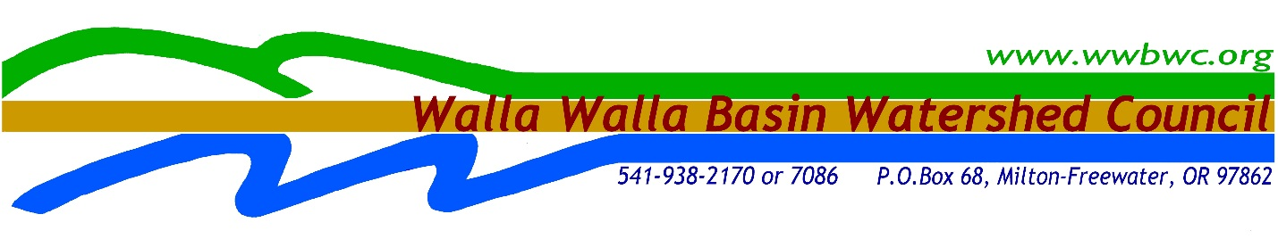

Walla Walla Basin Watershed Council
Hydrogeologic Consulting for Washington Basalt Aquifer Storage and Recovery (ASR) Preliminary Suitability Assessment
Request for Proposal

Publish Date: May 2nd, 2016

Request for Proposal Deadline: May 18th, 2016 @ 3pm local time

The Walla Walla Basin Watershed Council is in need of an agreement for Hydrogeologic Consulting for Washington Basalt Aquifer Storage and Recovery Preliminary Suitability Assessment to provide professional hydrogeologic services.
The agreement will be awarded and will be active until August 31st, 2016.
This Request for Proposal provides prospective respondents with information to prepare and submit proposals for Hydrogeologic Consulting for Washington Basalt Aquifer Storage and Recovery Preliminary Suitability.

Contents
Section 1: Introduction and Background 3
1.1 Request for Proposals 3
1.2 Submission of Proposal 3
1.3 Submittal Instructions 3
1.4 Background and Project Overview 4
Section 2: Administrative Requirements 5
2.1 Objective of Request for Proposal 5
2.2 Addenda to the Request for Proposal 6
2.3 Answers to Written Questions 6
2.4 Scope of Terms and Conditions 6
2.5 Award of Contract 6
2.6 Agreement 6
2.7 Respondent Responsible for Proposal Costs 7
2.8 Economy of Proposals 7
2.9 Proposal Binding 7
2.10 Notification 7
2.11 Right to Reject Proposals and Negotiation 7
Section 3: Proposal Content and Selection Process 7
3.1 General Submittal Requirements 7
3.2 Proposal Format 8
3.3 Technical Discipline Section Detail 8
3.4 Price Proposal 9
3.5 Selection Process 9
3.6 Request for Proposal Schedule 10
Attachment A – PRICE PROPOSAL FORM 11
Attachment B – AGREEMENT FOR PROFESSIONAL SERVICES 12
Attachment C: Draft Project Evaluation Template 15

Section 1: Introduction and Background

1.1 Request for Proposals
This Request for Proposal (RFP) contains instructions for proposals to be submitted and the required content to be eligible for consideration.
Any requests for clarification or additional information regarding submission of this RFP shall be submitted in writing via email (rfp@wwbwc.org). Written requests for interpretation, clarification, and/or additional information must be received no later than 3pm local time on May 9th, 2016.

1.2 Submission of Proposal
Respondents are requested to submit:
- One (1) copy of their technical proposal (electronic is preferred)
- One (1) copy of their price proposal, utilizing Attachment A as the template or similar
Proposals must be received no later than 3pm local time, May 18th, 2016, via email (rfp@wwbwc.org) or delivered to 810 S. Main Street, Milton-Freewater, OR 97862. Proposals submitted via email are preferred.
Responses must be in the format described below. Proposals shall be addressed as follows:

Walla Walla Basin Watershed Council
Attention: Steven Patten, Senior Environmental Scientist
810 S. Main Street
Milton-Freewater, OR 97862

1.3 Submittal Instructions
1. Proposals may be emailed, mailed or hand-delivered. If the proposal is sent by email, please call the WWBWC to ensure the email was received (541-938-2170). If the proposal is sent by mail, please allow extra time for delivery before the deadline.
2. The proposal must contain the signature of a duly authorized officer or agent of the Respondent’s company empowered with the right to contractually bind the Respondent.
3. Proposals become the property of the WWBWC upon receipt of same by the WWBWC. The content of proposals will be kept confidential until an award is made.
4. Proposals may be withdrawn or modified in writing prior to the proposal submission deadline. Proposals that are modified shall be resubmitted according to the above instructions prior to the submission deadline.

1.4 Background and Project Overview
The WA Basalt Aquifer Storage and Recovery (ASR) Preliminary Suitability Assessment area includes the Washington portion of the Walla Walla Basin. This project will specifically look at the basalt aquifers in areas between College Place and Touchet (Figure 1). This assessment will include review of existing data for the basalt aquifers, reviewing existing basalt wells, identify potential monitoring wells, description of state requirements for ASR and identification of a pilot project including development of a preliminary scope of work with a cost estimate for future funding. The expected outcome from this assessment is a determination of initial viability of using ASR for non-structural storage in the basin and identifying a pilot project with estimated project costs.

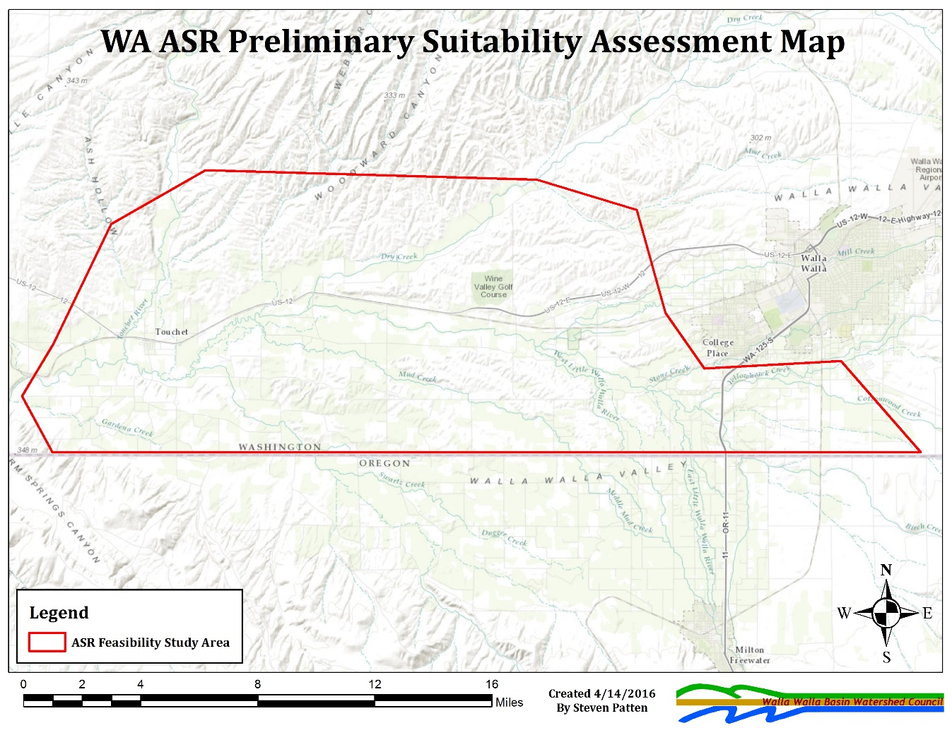
Key elements of the project will include:
- Review and compilation of existing data for basalt aquifer in the study area
- Review existing basalt wells for use in ASR projects
- Review existing basalt wells for use as potential monitoring wells
- Description of state requirements for ASR
- Identification of a pilot project and the development of a preliminary scope of work with cost estimates
- Take information from the assessment and complete the Project Evaluation Template for the potential pilot project (see Attachment C)
The Washington Basalt ASR Preliminary Suitability Assessment will help to determine the role ASR project(s) might play in the Walla Walla Basin Wide Instream Flow Enhancement Study. The proposed ASR projects would provide storage to improve water supplies for out-of-stream uses while improving instream flows in the Walla Walla Basin. These ASR projects would provide water storage for irrigation use (non-potable). The purpose of these storage projects would be to divert water during high flows (winter/spring) to store in the basalt aquifers which would be utilized later in the year (late spring/summer/fall) for irrigation use thereby reducing diversions from the Walla Walla River (or its tributaries).
This assessment will include a survey of the entire study area for the first four bulleted points above. The last two bulleted points, identification of a pilot project and project evaluation template, will focus on a single area/project as an example that could be implemented elsewhere in the basin.
Information for the identified pilot project from this assessment will need to be transferred to the Study’s Project Evaluation Template (Attachment C).
The selected contractor will work closely with WWBWC staff as part of the assessment process. The assessment process will also be overseen by the Managed Aquifer Recharge/Aquifer Storage and Recovery (MAR/ASR) Technical Work Group for the Walla Walla Basin Wide Instream Flow Enhancement Study. This assessment is expected to be completed by the end of August 2016 with draft documents/data/reports completed by August 1, 2016. WWBWC staff, MAR/AST Technical Work Group and state agencies will provide comment/review of drafts for integration in to the final work products.

Section 2: Administrative Requirements

2.1 Objective of Request for Proposal
The objective of this RFP is to provide sufficient information to enable qualified Respondents to submit written proposals for Hydrogeologic Consulting for Washington Basalt Aquifer Storage and Recovery Preliminary Suitability Assessment. The RFP is not a contractual offer or commitment to purchase products or services.
Information must be legible. Corrections and erasures must be initialized. Each proposal shall be accompanied by a letter signed by an authorized representative of the Respondent. The contents of the proposal submitted by the successful Respondent of the RFP may become part of any contract awarded as a result of this solicitation.

2.2 Addenda to the Request for Proposal
If it becomes necessary to revise any part of the RFP, an addendum will be placed online on the WWBWC website (www.wwbwc.org) by 3pm local time on May 11th, 2016. Respondents are responsible to check online prior to submission of their proposal.

2.3 Answers to Written Questions
Answers to written questions about the proposals will be provided by 3pm local time on May 11th, 2016.

2.4 Scope of Terms and Conditions
The general terms and conditions listed in the Agreement for Professional Services (Attachment B) shall govern any Agreements ensuing from this RFP.
The WWBWC prefers to use the terms and conditions in our Agreement, but will consider requested changes.

2.5 Award of Contract
Agreements may be negotiated with Respondents whose proposal is determined to be most responsive to the WWBWC’s needs and most advantageous to the WWBWC as solely determined by the WWBWC.
Award of an Agreement may be made without discussion after proposals are received. Proposals should, therefore, be submitted initially on the most favorable terms of qualifications and technical experience. The WWBWC reserves the right to reject any or all proposals.

2.6 Agreement
The WWBWC does not guarantee that it will request any or all services covered by the Agreement. Issuance of an Agreement will not give rise to a claim by Respondent for entering into such Agreement including, but not limited to, claims for anticipated profits or compensation for overhead or other related costs.
Award of an Agreement does not establish an exclusive agreement with the Respondent. The WWBWC reserves the right to obtain services from other sources.
The WWBWC will request services or assistance and Respondent shall review its resources to verify their availability to satisfy the WWBWC’s request. Respondent will provide a written response describing the approach to be taken for performing requested services, estimated cost, key team members and the schedule for completion. Services under the Agreement will be conferred by a Task Order and executed by both parties.

2.7 Respondent Responsible for Proposal Costs
The WWBWC is not liable for any cost incurred by any Respondent associated with the preparation of a proposal or the negotiation of an Agreement for services prior to the issuance of an Agreement. Respondent is responsible for costs associated with responding to the RFP including costs related to site visit(s) and estimate preparation(s) for work authorized under the Agreement.

2.8 Economy of Proposals
Respondent must submit a complete and concise response to the RFP, which will be retained by the WWBWC. Proposals should be prepared simply and economically, while providing complete details of the Respondent’s abilities to meet the requirements of the RFP.

2.9 Proposal Binding
Respondents are advised that proposals shall be binding upon the Respondent for sixty (60) days from the proposal due date. A Respondent may withdraw or modify their proposal any time prior to the proposal due date by a written signed request.

2.10 Notification
Each Respondent submitting a proposal will be notified in writing (email) as to acceptance or rejection of their proposal. The WWBWC plans to release such letters within thirty (30) days of the proposal submittal deadline. The WWBWC may delay this action if it is deemed in the best interest of the WWBWC.

2.11 Right to Reject Proposals and Negotiation
The WWBWC reserves the right to reject any and all proposals and to waive any formality in proposals received, to accept or reject any or all terms in the proposal, if it is deemed in the WWBWC’s best interest.
The WWBWC reserves the right to negotiate any and all elements of the proposal, if such action is deemed to be in the best interest of the WWBWC.

Section 3: Proposal Content and Selection Process

3.1 General Submittal Requirements
The following submittal requirements must be satisfied for each section of this RFP. The information will be used as the basis for selection.
Proposals made in a superfluous manner where technical sections submitted do not demonstrate discernible strength or potential value to the WWBWC may be disregarded altogether.

3.2 Proposal Format
The proposal format shall be as follows:
All Sections – The page limit includes tables, figures, photographs and other graphical representations, all of which must be included within the same contiguous section. Page limits refer to limits of text (i.e. double-sided prints will be counted as two pages).
Font Size – The font size for text pages shall be no smaller than 10 point. The overall proposal presentation must be legible. Illegible proposals will not be considered.
Proposal Presentation – A table of contents or similar must be utilized to clearly indicate subsequent sections of the proposal.
Cover Letter – One (1) page maximum. Page must be 8.5” x 11”.
Table of Contents – Provide an indication of the subsequent sections.
Company Background – Two (2) pages maximum. Pages must be 8.5” x 11”. At a minimum provide information relative to your company including a short description of the company and whether staff are licensed in Oregon, Washington or both.
Technical Discipline Section – Five (5) pages maximum. Pages must be 8.5” x 11”. Please describe your company’s expertise by providing examples of previous projects and their deliverables. See 3.3 for further details.
Staff Biographies – Four (4) pages maximum. Page must be 8.5” x 11”. Brief personnel sketches or summaries for key team members.
Terms and Conditions – There is no page limit but pages must be 8.5” x 11”. Respondents shall identify questions or suggested changes to the Terms and Conditions of the AGREEMENT FOR PROFESSIONAL SERVICES (Attachment B) should they be chosen by the WWBWC.

3.3 Technical Discipline Section Detail
The technical discipline section shall include the following information:
Project Experience – Relevant project experience in the technical discipline area. For previous projects please provide a brief description of the project. You may include photographs, graphs, or other graphics.

Proposed Approach of Scope of Work – Briefly but succinctly describe the approach the Respondent proposes to complete the feasibility study within the timeline and budget. This section should describe an approach to the project that shows an understanding of problems and tasks, is responsive to the stated scope and timeline of the project and is well-organized with clear articulation of the project.

Project Staff and Location – Briefly list project staff who will work on the project and the location(s) of the office(s) where project services will be performed, including the main project office location where the project team (potential project manager) will be based.

3.4 Price Proposal
Provide Respondent company’s billing structure, including labor rate structures by staff categories and other non-labor rates utilizing Attachment A – PRICE PROPOSAL FORM (Standard Rate Sheet) template or similar format. This template includes a table showing the company’s rates for the Agreement period. The rate table must provide information on all proposed mark-ups and fees, and will be incorporated into a selected company’s AGREEMENT FOR PROFESSIONAL SERVICES.

3.5 Selection Process
Professional companies will be evaluated on the Respondents relative experience and project staff (30%), approach of scope of work (40%), and the price proposal (30%).
Adequacy and Merit of Approach (40 points)
- Adequacy of the approach for addressing and completing tasks (20 points)
- Characterize existing conditions (5 points)
- Development of water quality treatment alternatives for pilot project (5 points)
- Adequacy of approach to meet timeline (5 points)
- Adequacy of approach for addressing permitting and regulatory processes for WA (5 points)

Experience and Project Staff (30 points)
- Qualifications of Respondent (prior experience with ASR feasibility studies similar to the propose project) (15 points)
- Company Resources available for the project (15 points)

Bid Price (30 points)
- The total price of the proposal (30 points)

3.6 Request for Proposal Schedule
The RFP Schedule is tentatively set as follows:
Publish Request for Proposals May 2nd, 2016
Written Questions Due 3pm local time on May 9th, 2016
Responses to Questions 3pm local time on May 11th, 2016
Publish Addendum if necessary 3pm local time on May 11th, 2016
Proposals Due 3pm local time on May 18th, 2016
Notice of Tentative Award Within 30 Days of Proposal Due Date

Attachment A – PRICE PROPOSAL FORM

Company Name:_______________________________________________________________________________________________
Position Title | Hour Rate
*All position titles to be used on Task Order Assignments must be shown
**All costs must be included in the hourly rates. No additional project costs will be allowed. Administrative expenses, including, but not limited to, the following should be incorporated into labor rates and shall not be billed as a separate charge:
- Telephone charges
- Postage and delivery
- Technology costs (computer usage, office equipment, etc.)
- Accounting
- Marketing

If your company is proposing reimbursement for travels costs, describe your travel policy (i.e. limits on meals, mileage rate and personnel hourly rate during travel time).
Please list applicable equipment charges and fees in the table below.

Applicable Fees/Equipment | Cost

Payment Terms – Net 30

Attachment B – AGREEMENT FOR PROFESSIONAL SERVICES
Agreement for Professional Services

Date: DATE Project Name: Washington Basalt Aquifer Storage and Recovery Preliminary Suitability Assessment
Walla Walla Basin Watershed Council, of 810 South Main Street, Milton-Freewater, OR (CLIENT) and ___CONSULTING FIRM/COMPANY NAME___, of ___ADDRESS___ (CONSULTANT) hereby agrees as follows:

CONSULTING SERVICES: The CLIENT agrees to secure the services of the CONSULTANT and the CONSULTANT agrees to assist CLIENT with hydrogeologic services for its Washington Basalt Aquifer Storage and Recovery Preliminary Suitability Assessment.

PROJECT NAME: Washington Basalt Aquifer Storage and Recovery Preliminary Suitability Assessment

SCOPE OF CONSULTANT SERVICES: The CONSULTANT shall provide consulting services to assist the CLIENT with the Washington Basalt Aquifer Storage and Recovery Preliminary Suitability Assessment for the Walla Walla Basin Integrated Flow Enhancement Study. Consulting services will include, but not be limited to, review and compilation of existing data for basalt aquifer in the study area, review existing basalt wells for use in Aquifer Storage and Recovery projects, review existing basalt wells for use as potential monitoring wells, description of state requirements (Washington) for Aquifer Storage and Recovery, development of a potential pilot project with estimated project costs, pilot project integration into the draft Project Evaluation Template.

CLIENT REQUIREMENTS: The CLIENT shall provide all information available on the project and direction in the work to be performed.

PERFORMANCE SCHEDULE: The start date for this project is the signature date of both parties and shall be completed by August 31, 2016.

CONSULTANT COMPENSATION: The consulting fee associated with project work will be based on a time and expense basis. The hourly labor rate fee for consulting shall be ____SEE ATTACHED PRICE SHEET____. Fees for expenses are listed on this agreement. Time and expenses for this project will not exceed ____BUDGET AMOUNT____ without a written amendment signed by both parties.

OTHER: The CONSULTANT will not perform any work without authorization from the CLIENT.

APPROVED BY:
CLIENT: CONSULTANT:
Walla Walla Basin Watershed Council COMPANY NAME
ADDRESS: ADDRESS:
810 South Main Street COMPANY ADDRESS
Milton-Freewater, OR 97862 COMPANY ADDRESS
TITLE: TITLE:
____________________________________________ ____________________________________________
SIGNATURE: SIGNATURE:
____________________________________________ ____________________________________________
DATE: DATE:
____________________________________________ ____________________________________________
PHONE: 541-938-2170 PHONE: COMPANY PHONE #
FAX: 541-938-2170 FAX: COMPANY FAX #
EMAIL: ___________________________________ EMAIL: __________________________________

General Conditions:
- Labor fees shall be as noted under ‘CONSULTANT COMPENSATION SHALL BE.’ or on an attached Rate Schedule. Expenses shall be reimbursed at cost and vehicle mileage expenses will be reimbursed at the federal mileage rate. Other out of pocket expenses such as permit, application, advertising, filing fees, sales tax and other services will be charged at cost.
- Invoices will be issued monthly quarterly and payment terms are Net 30.
- The CONSULTANT may provide estimates (opinions) of probable construction cost in performing services under this agreement. Any estimates or opinions of probable construction cost are prepared on the basis of the CONSULTANT’S experience and qualifications and represent CONSULTANT’S judgment as a professional generally familiar with the industry. The CLIENT acknowledges the CONSULTANT has no control over the contractor’s methods of determining prices, or the cost of labor, materials, or services furnished by others. CONSULTANT cannot and does not guarantee that proposals, bids or actual construction costs will not vary from CONSULTANT’S estimates or opinion of probable cost.
- The CONSULTANT agrees during the term of this agreement to keep in full force statutory workers’ compensation insurance including employer’s liability insurance of its employees, comprehensive general liability insurance covering bodily injuries in the amount of $1,000,000 and property in the amount of $1,000,000 per occurrence, with a non-cumulative annual aggregate of $1,000,000 for bodily injury and $1,000,000 for property damage. The CONSULTANT agrees to maintain a minimum of $50,000 of professional liability insurance during the term of this agreement.
- The CLIENT or CONSULTANT may terminate this agreement upon seven (7) days written notice. CONSULTANT shall submit an invoice for services performed up to the effective date of termination and the CLIENT shall pay CONSULTANT all outstanding invoices within thirty (30) days.

Attachment C: Draft Project Evaluation Template
DRAFT - WALLA WALLA BASIN INTEGRATED FLOW ENHANCEMENT STUDY
PRELIMINARY PROJECT PROPOSAL TEMPLATE
1. Title: | 2. Proposal Preparer(s):
3. Project Status: Identify whether the proposed project is a past, ongoing or new project and briefly explain the status of the project, including the requested role of the Flow Study in further consideration of the project. If past project, some of the questions below may not be applicable.
□ a. NEW PROJECT □ b. ON-GOING PROJECT □ c. PAST PROJECT

4. General Description of Proposal: Identify the category(s) and briefly explain the proposed project (e.g. location, infrastructure requirements, maintenance requirements, connection to other new, ongoing or past projects, other stakeholders, various sizing or phasing, etc.).
□ a. Water Conservation & Infrastructure □ b. Aquifer Recharge & Aquifer Storage and Recovery
□ c. Surface – Groundwater Source Switch □ d. Surface Water Storage □ e. Pump Exchange
□ f. Water Right Transactions □ g. Point of Diversion Transfers □ h. Other

5. Source of Produced Water: Mark all applicable and identify (water right number, shallow or deep basalt aquifer, stream name).
□ a. Existing Water Right

□ b. Groundwater

□ c. Surface Water

□ d. Other

6. Quantity/Timing/Location of Produced Water Instream: Estimate average amount of water, when and where. Can project be considered at various sizes(flow outputs) and/or considered in phases?
a. Acre-feet and/or Cubic-feet-per-second:

b. Timeframe(s):

c. Stream Reach Location(s):

□ d. UNKNOWN - Need more work (engineering/design/modeling, etc.) to estimate potential instream flow outputs of project. Will results of this work be concluded within one year to inform potential project flow outputs? Describe additional work needed and cost estimate.

7. Ability to Protect Produced Water Instream: Briefly explain how the produced water will be quantified, monitored and protected instream or why it is not currently protectable.
□ a. YES - protection under existing regulations expected to WW River mouth or in limited reach?

□ b. NO or □ c. UNKNOWN – Results and implementation of flow protection study likely necessary to ensure flow protection.

8. Cost Estimates: Provide known and estimated costs to develop and implement the project.
a. Project Development and Design:

b. Project Construction:

c. Construction cost per AF and/or CFS:

d. Project Annual O&M:

□ c. UNKNOWN - Need engineering/design work to estimate costs

9. Secured Costs: Has any funding been secured in the past or currently and what is source?
10. Other Potential Project Advantages: In addition to helping address flow targets and basin-wide flow issues (Endangered Species Act, Tribal Water Rights, Clean Water Act, etc.), briefly explain other potential benefits (e.g. reduced O&M costs, restores/mimics ecological processes, cropping flexibility, )
11. Other Potential Project Disadvantages: Briefly explain potential drawbacks of the proposal (e.g. reduced GW supply - recharge mitigation need, increased O&M costs, legal implications)
12. Estimated Time Frame to Implement Project?

